**Sprint 3 - System Design Document**

**December 2, 2020**

Page Break

**Table of Contents**

**1.EXECUTIVE SUMMARY 2**

1.1Project Overview 2

1.2Purpose and Scope of this Specification 2

**2.PRODUCT/SERVICE DESCRIPTION 2**

2.1Product Context 2

2.2User Characteristics 2

2.3Assumptions 3

2.4Constraints3

2.5Dependencies 3

**3.REQUIREMENTS 4**

3.1Functional Requirements 4

3.2Security5

*3.2.1Protection5*

*3.2.2Authorization and Authentication 5*

3.3Portability 5

**4.REQUIREMENTS CONFIRMATION/STAKEHOLDER SIGN-OFF 5**

**5.SYSTEM DESIGN 5**

5.1Algorithm 5

5.2System Flow6

5.3Software6

5.4Hardware6

5.5Test Plan7/8

5.6Task List/Gantt Chart 8

5.7Staffing Plan 9

1. Page Break
2. Executive Summary
3. ***Project Overview***

The group must design and code a program that tells the robot to maneuver around several obstacles then race to knock pins down.

1. ***Purpose and Scope of this Specification***

This sprint is to test our control over the robot we were given. It will display to the professor our ability to code a successful and applicable program.

**In scope**

* Avoid all obstacles
* Only run on assigned course or the program will not work

**Out of Scope**

* Do not run outside or on another course
* Do not run on a bumpy surface

1. Product/Service Description
2. ***Product Context***

Self contained defines something complete on its own and doesn't need anything else. That being said, The product is independent and self contained, as it doesn’t need any further assembly to function. However, it does need to connect to a system . The user needs to download the Sphero app onto their smartphone or computer, and from there they would need to make an account. After the short process, they would need to connect the robot to the app, by clicking ___________. From, there, the user and the team would be able to make their code.

1. ***User Characteristics***

* Student/faculty/staff/other: The robot was made for beginners regardless of age who are interested in learning the mechanics of coding. This could include students, faculty members, staff or any person with a willing mindset. The students could use Sphero robots to complete a project. The faculty and staff could use the robot to teach their students coding.
* Experience: Both the app and the robot do not require any prior experience with coding. In fact, these were made to introduce coding in a more simple manner using block code. This type of code has many blocks in the English language in which the user can understand. The user can then drag and drop the boxes to fit each other like a puzzle. Beginner users including students, faculty, and adults will be able to use these successfully.
* Technical expertise: The software within the Sphero is actually simple to use because it’s in block code. However, for a challenge, users have the option to translate the code into Javascript

1. ***Assumptions***

Some assumptions that affect the requirements is the robot availability and the user expertise. Due to the COVID pandemic, stricter rules were enforced as to how the robot would be picked up. This ranged from the time scheduling, the amount of time waiting, and the amount of people allowed to enter the area. Not all of us were able to enter the campus as a team. This was mostly due to some members living farther away. Fortunately, we were able to schedule a time convenient. More so, the robots did not run out of supply when that group member came. As per user expertise, we had a range of abilities through our group. Some know aspects of coding, while some are new at it. Some had more previous experience coding languages, while some did not. However, the block code was certainly an excellent way to introduce coding in a more simpler manner. In this case, it did not matter whether we had experience coding languages or not, because we all understood block code. As per the user expertise of Sphero, none of the group members had prior experience with the robot, so we were all new at it. However, with time and practice, we were able to collaborate on code and get the robot to function.

1. ***Constraints***

* Audit functions (audit trail, log files, etc.): Data that was lost or not saved during the trials
* Access: User access to the app.
* Management: The responsibilities of completing all the necessary tasks. This could be done through the “divide and conquer” approach, dividing tasks amongst the strengths of the group members. One group member is appointed head, who shall be making sure everything is run smoothly, along with the fact that every member must be doing their job to the best of their ability.
* Security: Checking if the interface is protected from bugs and malware. Although it hasn’t happened, a virus on the user interface can definitely cause delay in the project completion.

1. ***Dependencies***

* This new product will require a download of Sphero from a smartphone, computer or any touch screen device.
* A certain speed must be set for the robot efficiently to reach the cones and turn at the appropriate timing.
* Familiarity with the app is recommended to gain more experience along with finishing the code on time.
* A Sphero account must be created before the robot could be used.
* The robot must be connected with the smartphone in order to implement code into it.

1. Requirements
2. ***Functional Requirements***

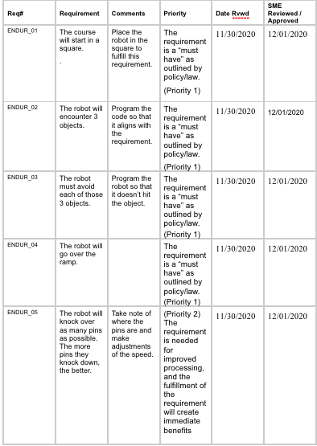

***Security***

1. **Protection** : To protect from prying eyes and malicious intent these are the measures recommended:

* encryption
* Backups made of program
* Private collaboration repositories

1. **Authorization and Authentication**

* 2 Step authentication
* Malware detecting
* Repository is only open to verified collaborators.

1. ***Portability***

* 100% of the hardware relies on host dependant code;
* The block code for this type of program is host dependant and needs the Sphero compiler, however the javascript can be created outside of the honest environment;
* Program can use Javascript code as well as the Sphero block code;
* Program can be run and written on multiple platforms from phone to tablet to desktop

1. Requirements Confirmation/Stakeholder sign-off

|  |  |  |
| --- | --- | --- |
| **Meeting Date** | **Attendees (name and role)** | **Comments** |
| 11/29/20 | Thomas Tacinelli, Ryan Wire, Ashley Zingillioglu | confirmed all |
|  |  |  |

1. System Design

This section will provide all details concerning the technical design, staffing, coding, and testing the system

1. ***Algorithm*** 
   1. **Roll at 315 degree heading for 3’3”, then stop**
   2. **Roll at 45 degree heading for 3’4”, then stop**
   3. **Roll at 310 degree heading for 3’10”, then stop**
   4. **Roll at 55 degree heading at faster speed for 4’0” to jump the ramp**
   5. **Will roll to the 7’5 mark**
   6. **Delay for 2s**
   7. **Roll at 178 degree heading at a fast speed for 9’5”, then stop**

1. ***System Flow***

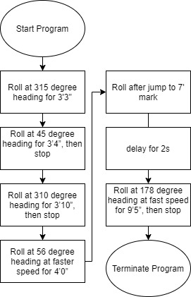

1. ***Software***

Program will be created using a mix of block code and javascript. Block code will be sourced from Sphero API and javascript will be used to convert collaboration back into block cod

1. ***Hardware***

This program will be developed on the Sphero Block Code generator and use Github repositories as the collaboration space. The robot itself is a sphero model.

1. ***Test Plan***

|  |  |  |  |  |  |
| --- | --- | --- | --- | --- | --- |
| **Reason for Test Case** | **Test Date** | **Expected Output** | **Observed Output** | **Staff Name** | **Pass/Fail** |
| Robot must start in a square | 11/30 | Robot will start in a square. | The robot did start in a square. | Thomas T | Pass |
| Robot will follow the course and avoid the first obstacle. Robot will roll 320 degrees at 70 speed for 2.5 seconds. | 11/30 | Robot will follow the path and avoid the first obstacle. | Robot did not follow the path as it was going too far towards the right. So much so it hit the first obstacle. Robot also seemed to be moving too fast. | Thomas T | Fail |
| Robot will follow the course and avoid the second obstacle. Robot will roll 50 degrees at 70 speed for 2.7 seconds. | 11/30 | Robot will follow the path and avoid the second obstacle. | Robot did not follow the path as it went too far towards the right once again. So much so it did not even stay on course. Robot also seemed to be moving too fast. | Thomas T | Fail |
| Robot will follow the course and avoid the third obstacle. Robot will roll 320 degrees at 70 speed for 2.8 seconds. | 11/30 | Robot will follow the path and avoid the third obstacle. | Robot did not follow the path as it went too far the right once again. Because the second turn was so off course, this led the third turn to also be off course by quite a lot. Robot also seemed to be moving too fast. | Thomas T | Fail |
| Robot will then go over the ramp. Robot will roll 50 degrees at max speed for 2 seconds in order to complete the ramp and stop at the correct point. | 11/30 | After the robot follows the guided path and avoids all obstacles. The robot is expected to complete the ramp and stop at the correct point. | Since the robot did not follow the path and did not avoid the three obstacles, this led the robot to completely miss the ramp as it was too far to the left by several inches. | Thomas T | Fail |
| Robot will complete the course by knocking down as many pins as possible. Robot will roll 180 degrees at 70 speed for 7 seconds in order to complete the course and knock all the pins down. | 11/30 | Once the robot completes the ramp jump and stops at the correct point. The robot is expected to turn and follow the guided path until all of the pins are knocked down. | Since the robot missed the ramp entirely, this of course affected its ability to complete the course and knock all the pins down. The robot was too far off course and so it finished no where close to the pins. | Thomas T | Fail |
| Robot will follow the course and avoid the first obstacle. Robot will roll 315 degrees at 50 speed for 2.1 seconds. | 12/1 | Robot will follow the path and avoid the first obstacle. | Robot followed the guided path correctly and avoided the first obstacle. | Thomas T | Pass |
| Robot will follow the course and avoid the second obstacle. Robot will roll 45 degrees at 50 speed for 2.25 seconds. | 12/1 | Robot will follow the path and avoid the second obstacle. | Robot followed the guided path correctly and avoided the second obstacle. | Thomas T | Pass |
| Robot will follow the course and avoid the third obstacle. Robot will roll 310 degrees at 50 speed for 2.3 seconds. | 12/1 | Robot will follow the path and avoid the third obstacle. | Robot followed the guided path correctly and avoided the third obstacle. | Thomas T | Pass |
| Robot will then go over the ramp. Robot will roll 55 degrees at max speed for 1.72 seconds in order to complete the ramp and stop at the correct point. | 12/1 | After the robot follows the guided path and avoids all obstacles. The robot is expected to complete the ramp and stop at the correct point. | Robot completed the ramp jump and stopped at the correct point. | Thomas T | Pass |
| Robot will complete the course by knocking down as many pins as possible. Robot will roll 178 degrees at 75 speed for 5.2 seconds in order to complete the course and knock all the pins down. | 12/1 | Once the robot completes the ramp jump and stops at the correct point. The robot is expected to turn and follow the guided path until all of the pins are knocked down. | Robot turned correctly and thus followed the path until the robot knocked down all of the pins. | Thomas T | Pass |

1. ***Task List/Gantt Chart***

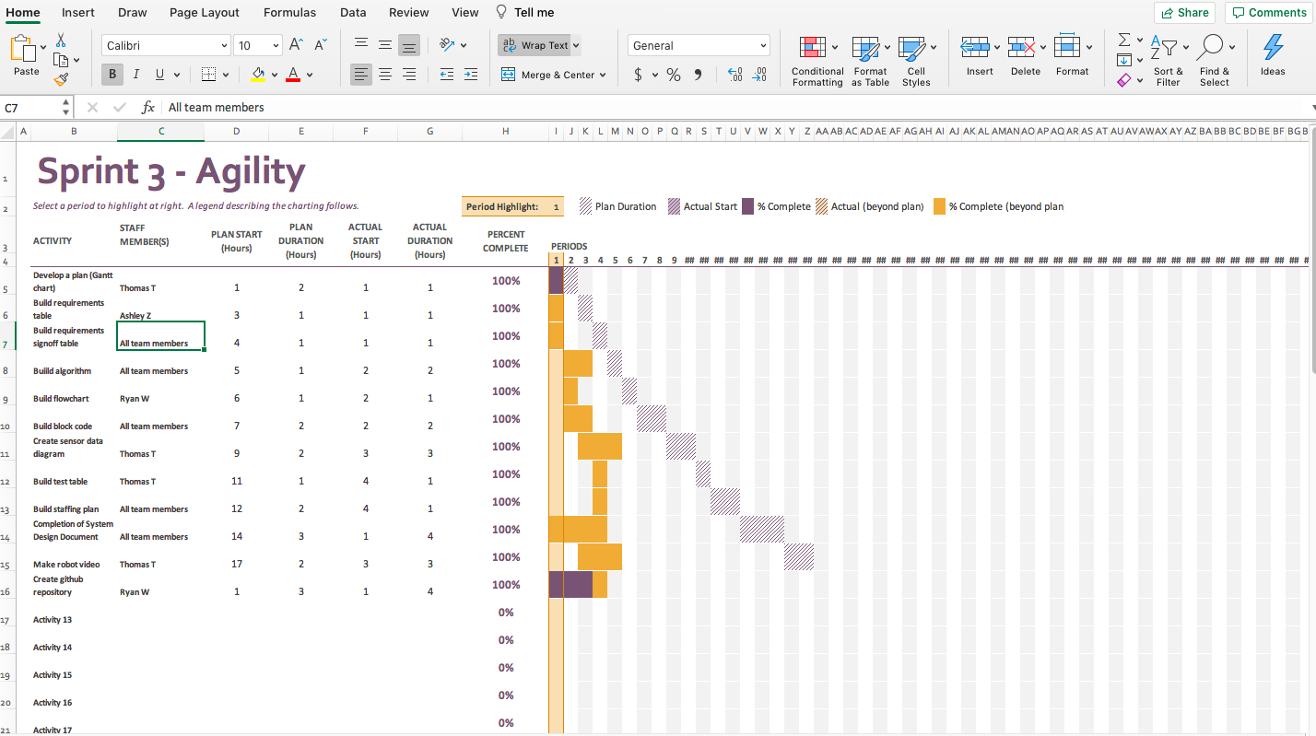

1. ***Staffing Plan***

Insert a chart/table that depicts the roles and responsibilities of each team member that worked on this project

|  |  |  |  |
| --- | --- | --- | --- |
| Name | Role | Responsibility | Reports To |
| Ryan | Project Manager | Finalizing SDD, ensuring group mates are fulfilling their roles, and making sure all requirements are met.  Created flowchart |  |
| Ashley | Documentor | In charge of creating requirements chart, completed sub section 3 and 4  Created the algorithm |  |
| Thomas | Tester | Creation of the Gantt chart, create sensor data diagram, build test table, and create the robot video. |  |

